Heart Disease Analysis Dashboard
1. Project Overview
This project focuses on analyzing heart disease patient data using Excel and Power BI. The main objective of the project is to study survival patterns among heart disease patients and understand the impact of factors such as age, smoking, diabetes, anaemia, high blood pressure, serum creatinine, and ejection fraction on patient survival.
An interactive dashboard was created in Power BI to visualize important insights and compare survival trends for male and female patients.

2. Dataset Summary
The dataset contains information about heart disease patients and their medical conditions.
Features Used
- Age
- Gender
- Survival Status
- Smoking
- Diabetes
- Anaemia
- High Blood Pressure
- Serum Creatinine
- Ejection Fraction
Tools Used
- Microsoft Excel
- Power BI

3. Dashboard Analysis
Overall Heart Disease Analysis Dashboard
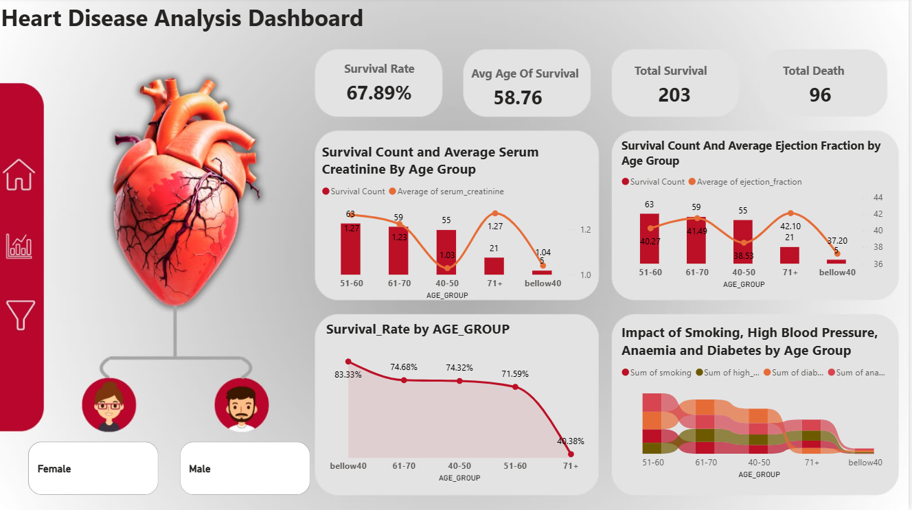
This dashboard provides a complete overview of all patients in the dataset.
Key Observations
- Total Survival: 203
- Total Death: 96
- Survival Rate: 67.89%
- Average Age of Survival: 58.76 Years
The dashboard shows that the majority of patients survived. The highest survival count is observed in the 51–60 and 61–70 age groups. The survival rate decreases significantly for patients above 70 years of age.
The dashboard also highlights the impact of smoking, diabetes, anaemia, and high blood pressure across different age groups.

Female Heart Disease Analysis Dashboard
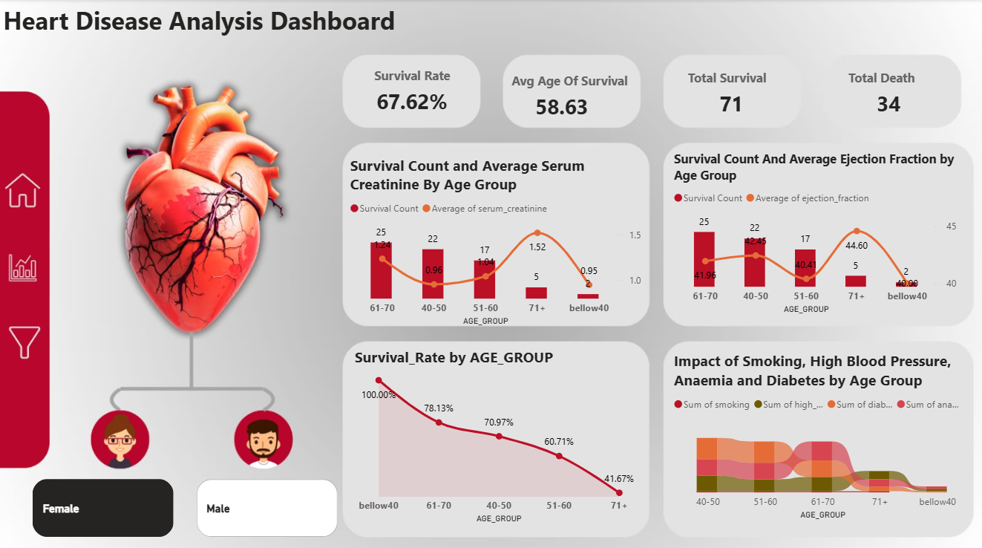
This dashboard focuses only on female patients.
Key Observations
- Total Survival: 71
- Total Death: 34
- Survival Rate: 67.62%
- Average Age of Survival: 58.63 Years
Among female patients, the highest survival count is observed in the 61–70 age group. The survival rate is highest in patients below 40 years of age and gradually decreases with increasing age.
The dashboard also shows the distribution of medical conditions such as diabetes, smoking, anaemia, and high blood pressure among female patients.

Figure 3: Male Heart Disease Analysis Dashboard
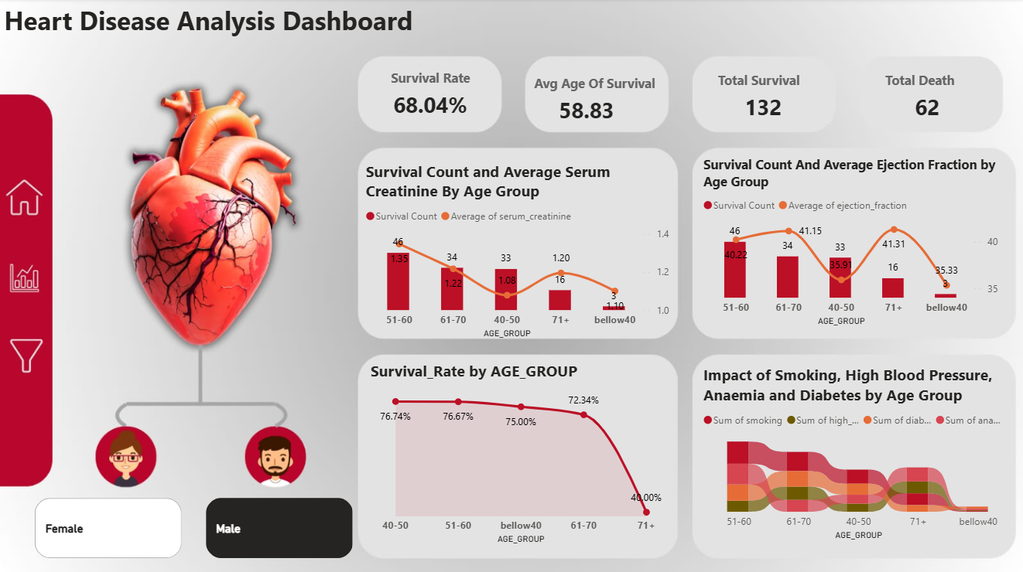
This dashboard focuses only on male patients.
Key Observations
- Total Survival: 132
- Total Death: 62
- Survival Rate: 68.04%
- Average Age of Survival: 58.83 Years
Male patients have a slightly higher survival rate than female patients. Similar to females, the survival rate decreases in higher age groups. The 51–60 and 61–70 age groups contribute the highest number of surviving patients.
The dashboard also provides insights into the impact of smoking, diabetes, anaemia, and high blood pressure on survival.

4. Key Findings
- The overall survival rate is approximately 68%.
- Male patients have a slightly higher survival rate compared to female patients.
- The average age of surviving patients is around 59 years.
- The highest survival count is observed in the 51–60 and 61–70 age groups.
- Survival rates decrease significantly in patients above 70 years of age.
- Medical conditions such as smoking, diabetes, anaemia, and high blood pressure show noticeable effects across different age groups.
- Younger patients generally have better survival rates compared to older patients.

5. Conclusion
This project helped in understanding heart disease patient data through data visualization and dashboarding techniques. Using Excel and Power BI, important patterns related to patient survival, age groups, and medical conditions were identified.
The analysis shows that age plays an important role in survival outcomes. Patients in younger age groups tend to have better survival rates, while survival decreases among older patients. The dashboard provides an easy way to explore and compare survival patterns for both male and female patients.

